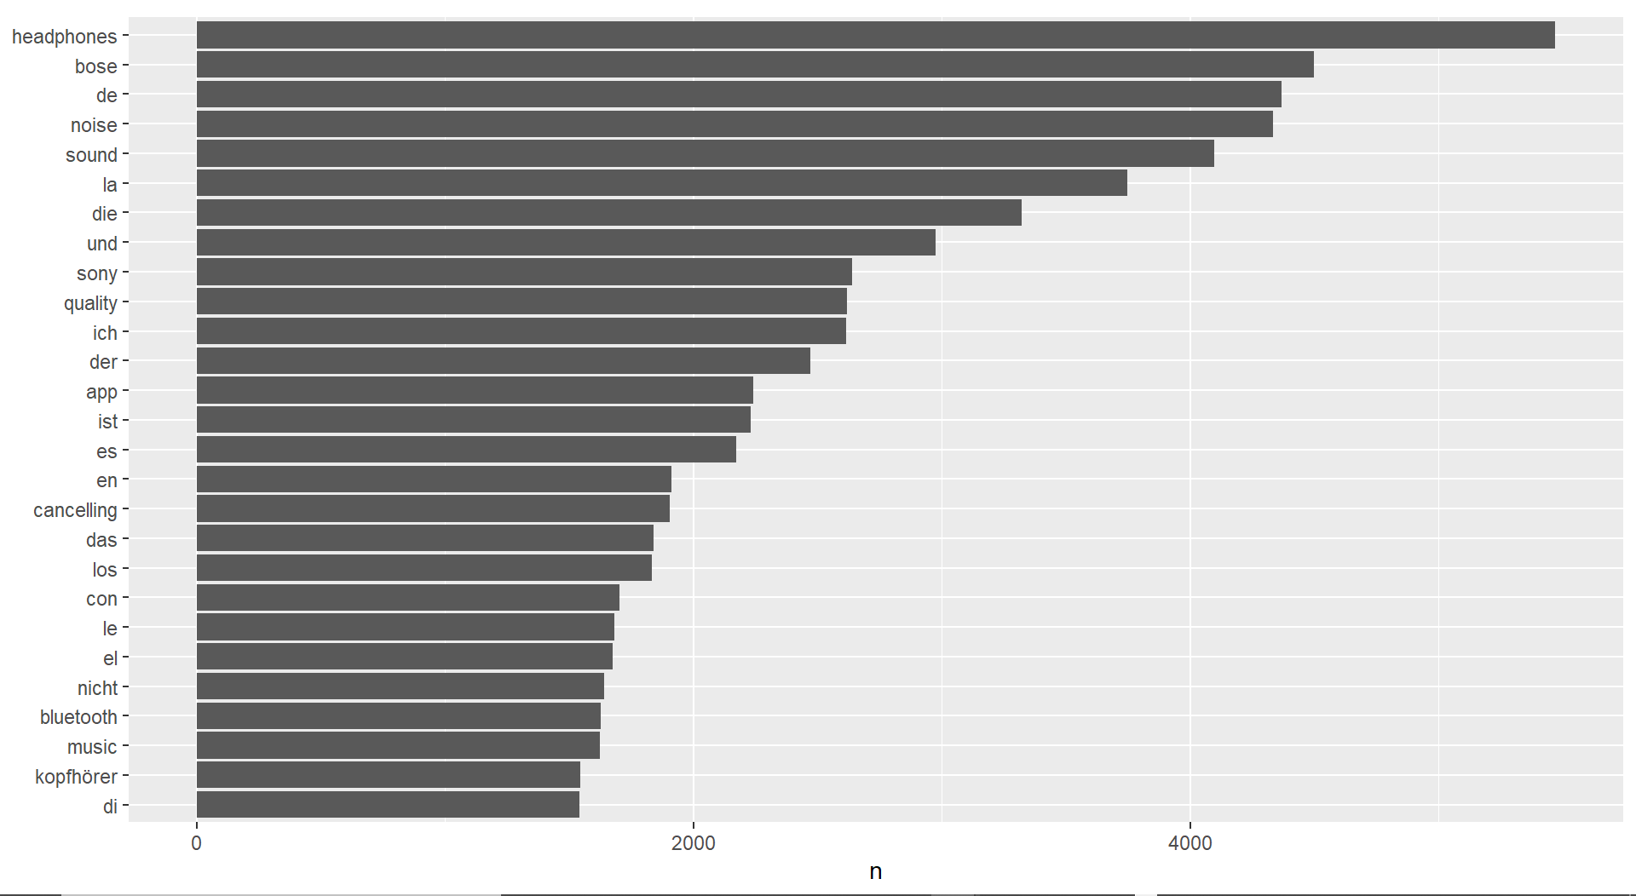
Token frequency

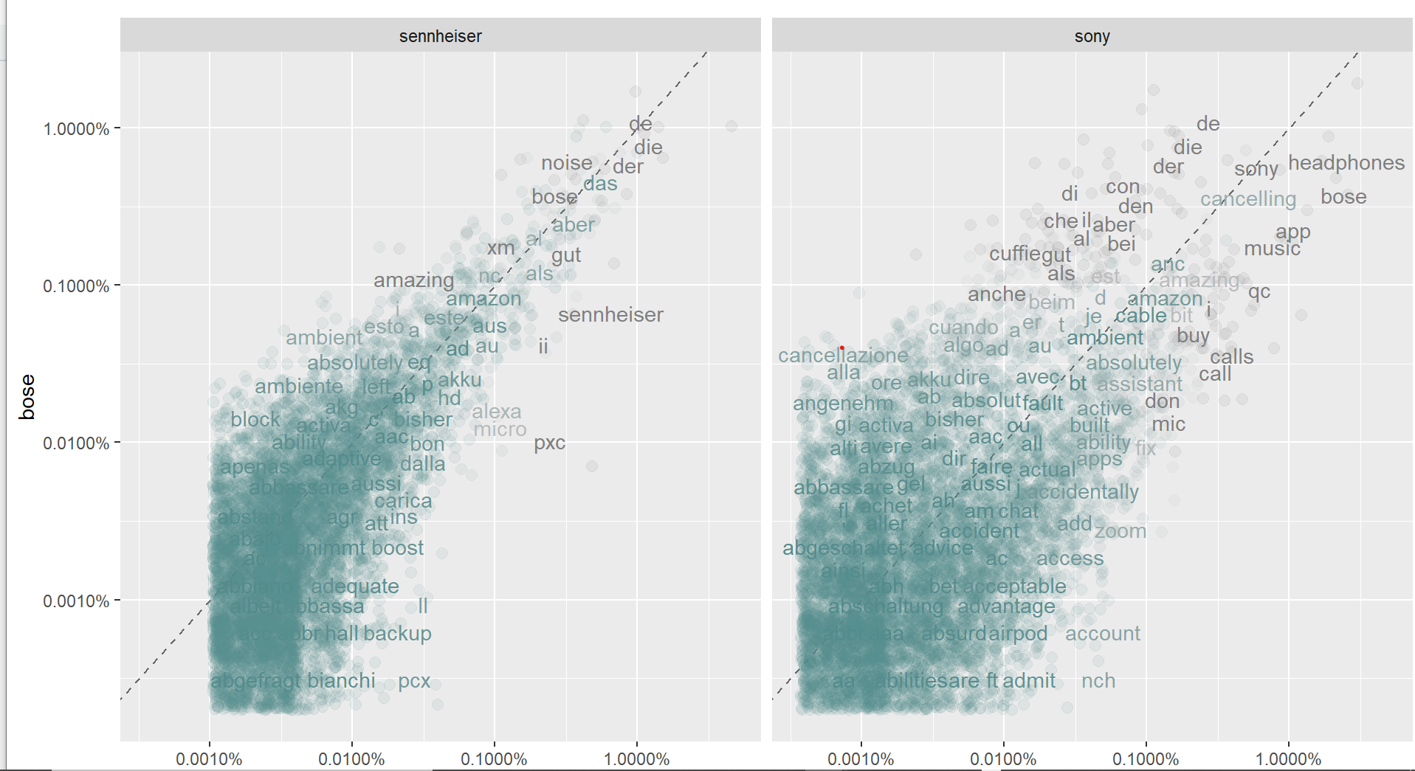
Correlograms- Correlation of tokens between Bose and Sennheiser & between Bose and Sony
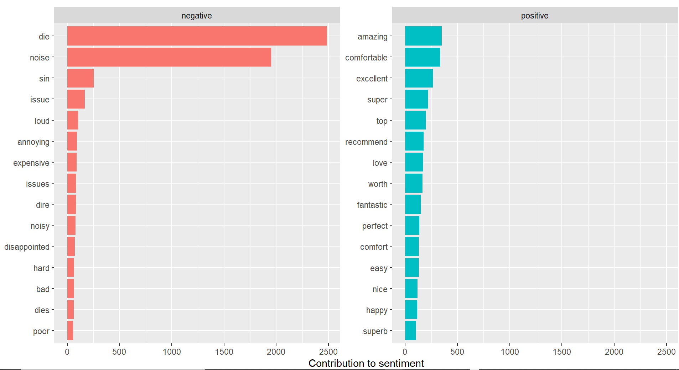
Sony positive and negative words for Sony headphones

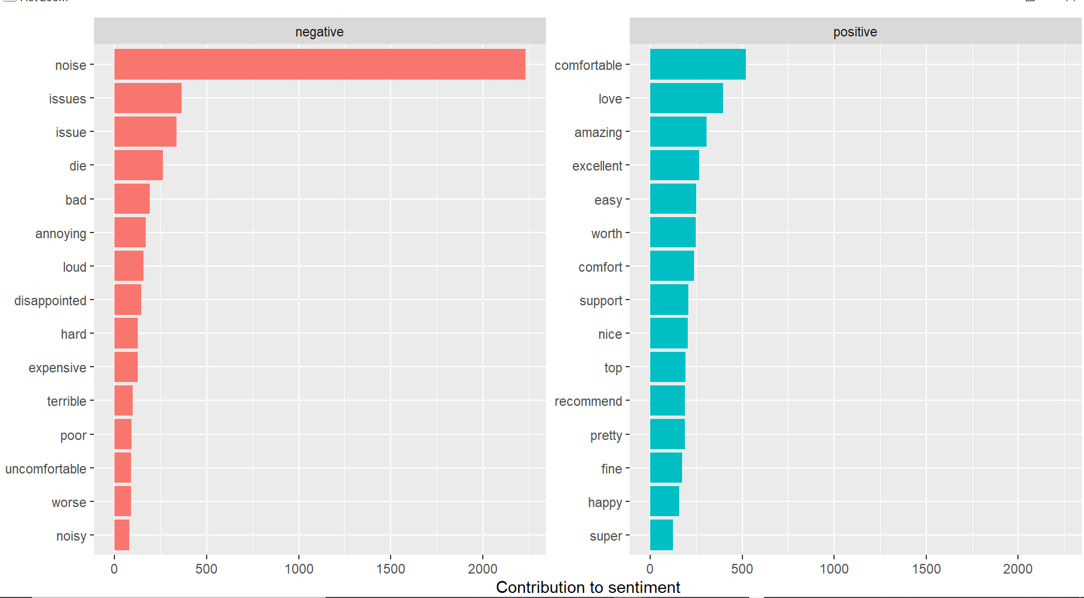
Positive and negative words for Bose headphones

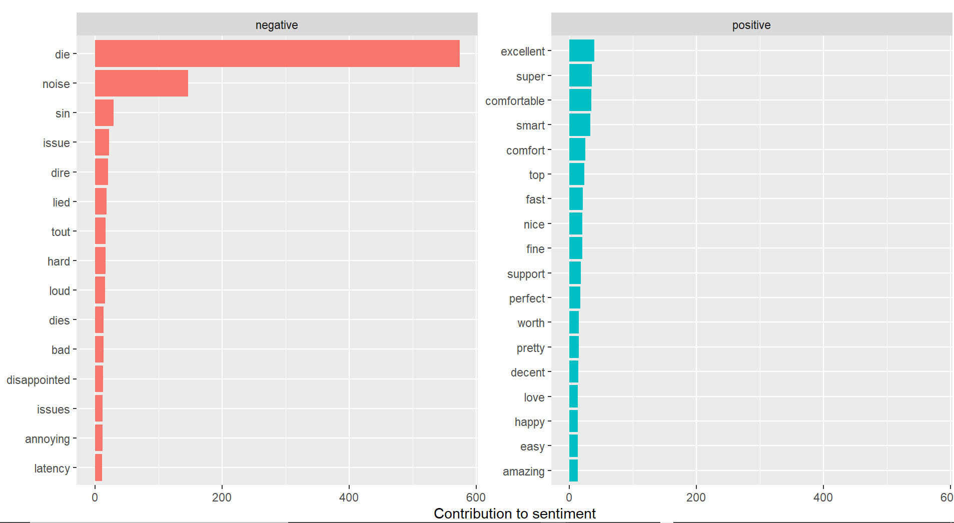
Positive and negative words for Sennheiser headphones

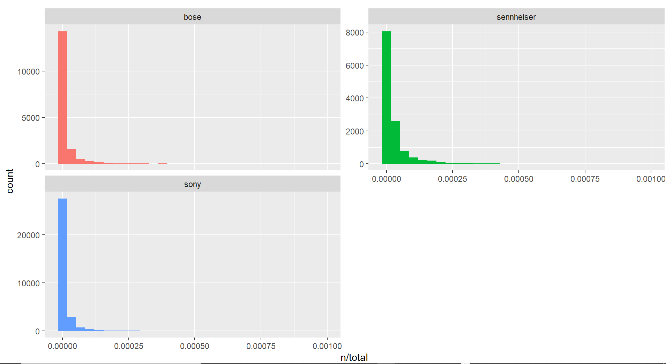
IDF for Headphones- Reviewing tokens with high/unique business values

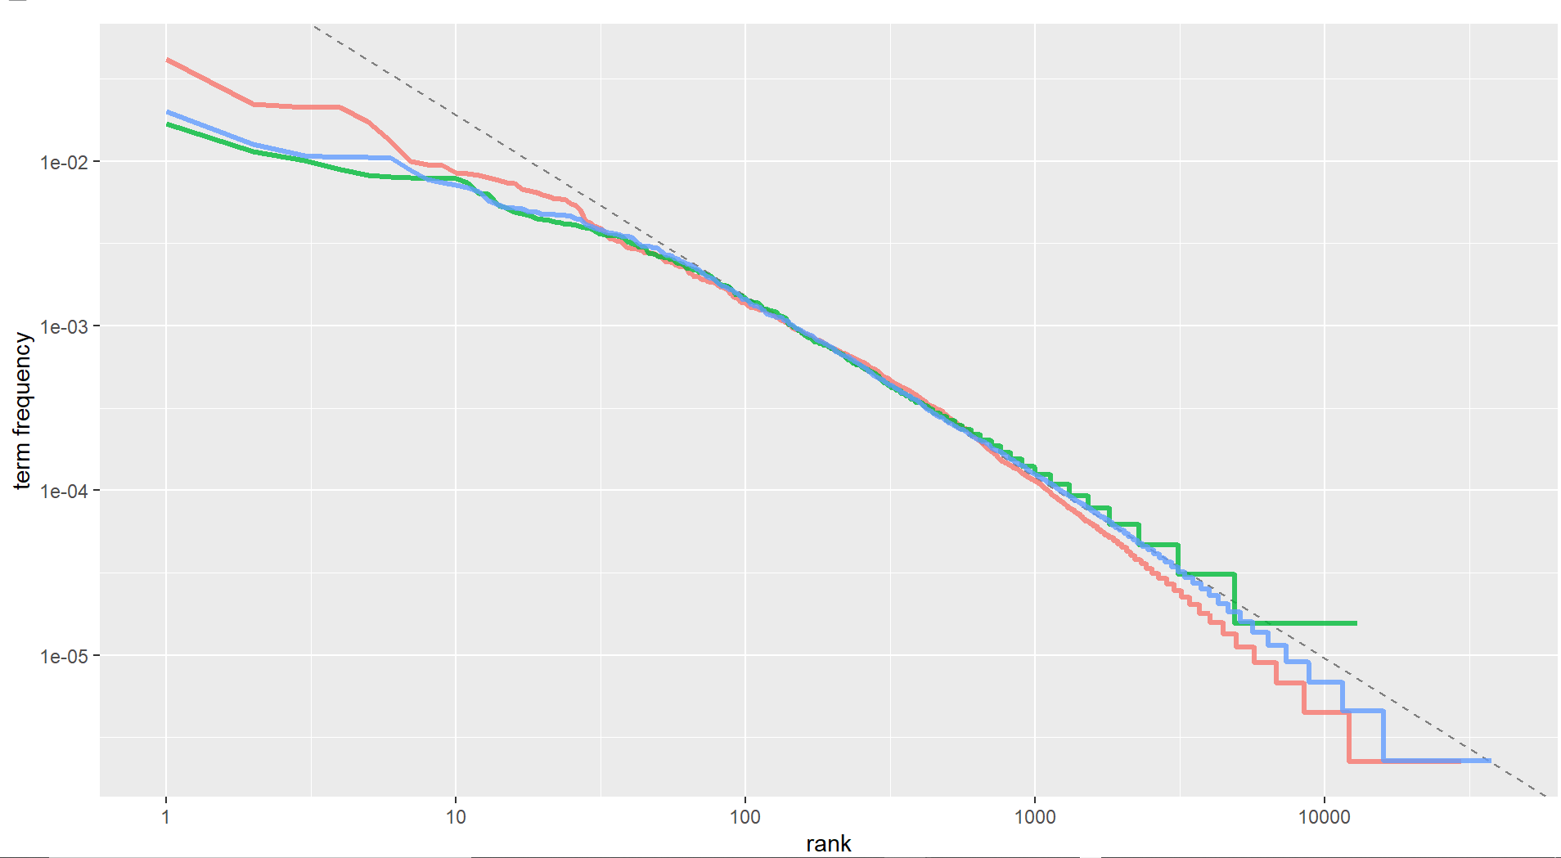
ZIPF’S Law - Rank and term frequency relationship (inverse)

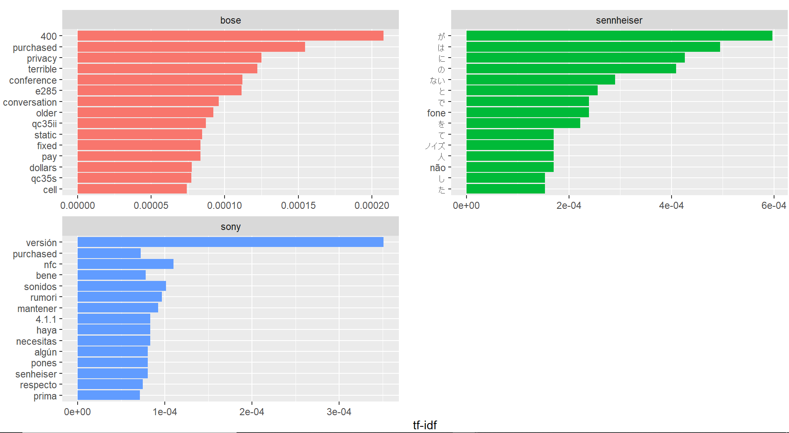
TF-IDF- tokens with unique business value

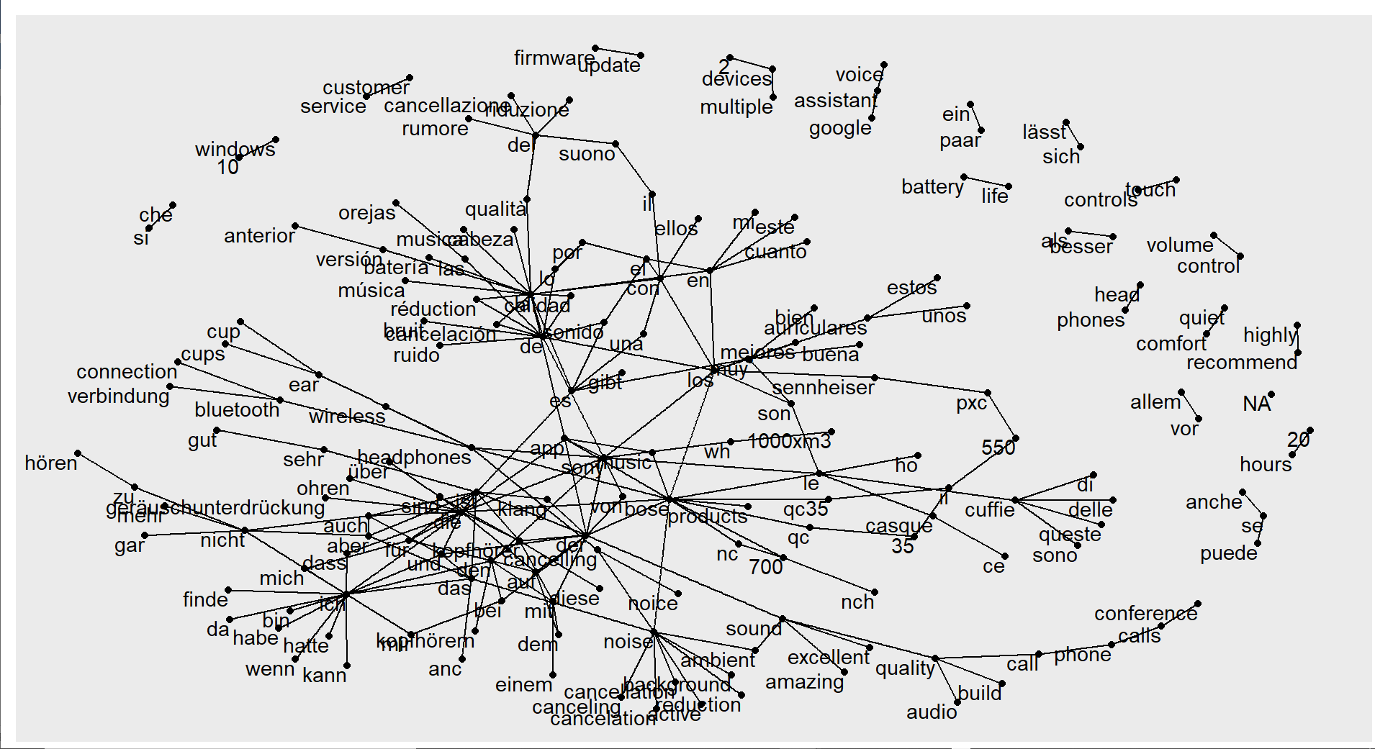
Bigram network for Headphones

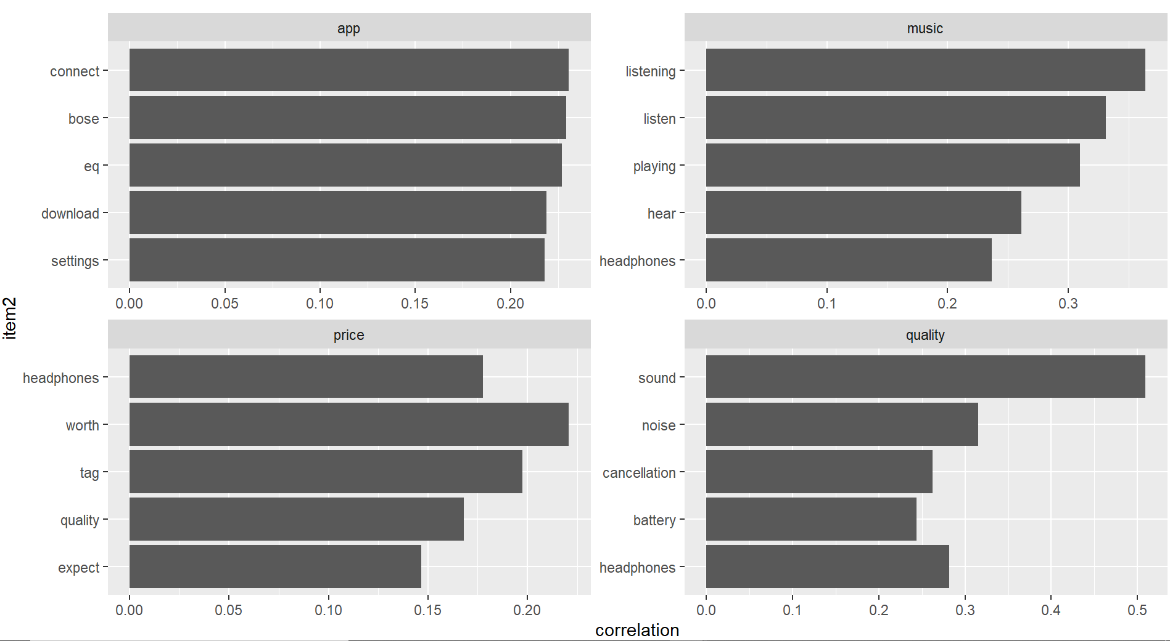
Pairwise correlation between word

